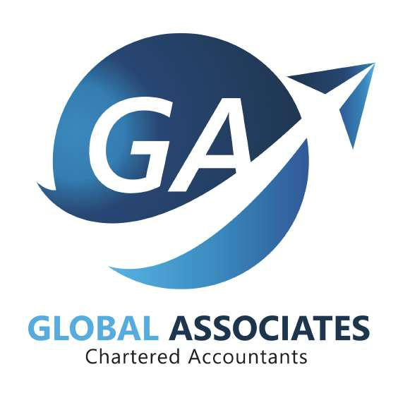



**ABOUT*GA*GLOBALASSOCIATES**

Global Associates is an organization of substance with a full service capability available in Sri Lanka. We construct our team to re ect your organization structure. We make all aspects of our service delivery transparent to the client. Our performance is pre-scheduled, agreed with you for deliverables, timetable and maximum cost e ectiveness. Our aim is to beat your expectations from any assignments. The approach we adopt ensures that we bring our views to you about business operations as well as nancial and legal compliance.

Your views on the quality of services delivered by Global Associates are sought by the managing partner of the rm. We will take action promptly if you feel it is needed. We are experienced in serving complex organizations and we are happy to provide site references to support this claim. We know that clear communication is essential to our service provision. The client service role is judged by the e ectiveness of our communication with clients and with our team.



**OUR KEY RESOURCE PERSONS**

**Mr. M.D.M Aashikkhan*GA***-Technical&Managing Partner

**Mr. Mohamed Rizkhan** - Executive Manager & ERP Consultant

|  |  |  |
| --- | --- | --- |
| **M. D. M. Aashikkhan** | ***GA*** |  |
|  |  |
| Managing Partner | **GLOBAL ASSOCIATES** |  |
| (FCA, FCCA, ACMA, CGMA, AIPA, |  |
|  |  |
| ASCMA, ACFE, MAAT) | **Chartered Accountants** |  |
|  |  |



Mohammed Aashikkhan is the Managing Partner and is responsible for the Assurance and Advisory services, Tax and Business Community Training offered by the firm. He is the technical & office partner for the firm and for this assignment, and our team will be advised on technical matters by him.

He is based in Sri Lanka, UAE and QATAR and has been involved in audit, consultancy and training activities in Sri Lanka, UAE and Qatar for over 18 years. His ability to quickly comprehend core issues in general and his experience in other business ventures in the Asia and Middle East will enable the team to develop and deliver high quality and effective assurance solutions.

During his career, Mohammed***GA***Aashikkhanhasgainedextensive experience in audit, accounting, development of policies and procedures, taxation, business community training, and related services. His client portfolio covers a wide variety of industries including oil and gas, telecommunication, utilities, banks, petrochemical and other downstream sector businesses, construction and manufacturing. He has advised a number of clients on assurance and advisory assignments in Sri Lanka, UAE and Qatar.

Mohamed Aashikkhan carries a vast amount of professional experience, exceeding 16 years in assurance, advisory, internal audit, accounting and management & financial consulting services with major Audit firms including Ernst & Young (EY), Price waterhouse Coopers (PWC) and Morrison KSI.

Mohamed Aashikkhan was employed by Ernst & Young Qatar as Senior Manager before establishing Global Associates for a period of 7 years and he was instrumental in establishing ABACUS UAE and NAD Qatar.

He specializes in providing professional consultancy services such as drafting policies and procedures, feasibility study, business planning, and financial & management consultancy and is an assurance services expert. 

Mohamed Aashikkhan is also a leading training provider for financial management, management accounting & financial accounting, international and local qualifications mainly chartered accountants Sri Lanka, ACCA UK, CIMA UK, CMA US, CPA US, AAT SL, CMA SL, and CFE US.

**Relevant Industries of Expertise:**

1. Banking & Finance
2. Airlines & Aviation
3. Energy & Utilities Sector
4. Hospitality 
5. Trading & Manufacturing
6. Retail Trading
7. Healthcare
8. Telecommunications

***GA*** 

**Mohamed Rizkhan**

Executive Manager & ERP Consultant

(MSc, ACCA, OCP, DNIIT) **GLOBAL ASSOCIATES**

**Chartered Accountants**

Mohammed Rizkhan is the Executive Manager of the firm with more than 15 years experience in Finance, Management Accounting, Costing and ERP applications , in addition to this Mohamed Rizkhan is possessing vast experience in advisory services, financial analysis, financial management, risk management, statutory audit services, content development and internal audit services.

Mohamed Rizkhan also specialized in implementing and training ERP business applications such as ORACLE and SAP for larger and SME companies, development of procedure manual for system development and in addition to his working experience, Mohamed Rizkhan counts more than 10 years of lecturing and training experience, preparing students for the professional examinations like CIMA, ACCA, ISACL, etc ***GA***

**Relevant Industries of Expertise:**

**8** Trading & Manufacturing

**8** International Trading

**8** Energy & Utilities Sector

**8** FMCG

**8** Education and Training



**OUR SERVICES**

|  |  |  |  |
| --- | --- | --- | --- |
| **** | External Audit | **** | Bookkeeping |
| **** | Internal Audit | **** | Financial Management |
| **** | Financial Statements Preparation | **** | Compliance Audit |
| **** | Budgeting | **** Forensic Audit and Investigation | |
| **** | Payroll Services | **** | Business Valuation Service |
| **** | Outsourced Accounting Services | **** | Feasibility Study |
| **** Tax Return and Fillings | | **** | Start-Up Assistance |
| **** | Proactive Quarterly Review | **** Business Planning and Budgeting | |
| **** Access to Real Time Accounting Softwares | | **** ERP Consultancy & Implementation | |
|  |  | **** Business Process Re-engineering (BPR) | |

**Take control of your Business** from basic bookkeeping to more complexfinancial needs.



***GA*CONTACTUS**

Phone: +94 81 222 5488 Mobile : +94 77 765 45 09

: +94 76 476 02 25

Email: info@gakandy.com Website: www.gakandy.com

Corporate Head Office:

No. 291, D.S Senanayake Street, Kandy - Sri Lanka

COLOMBO | TRINCOMALEE | MAHIYANGANA | MARUTHAMUNAI] | ANURADHAPURA

INTERNATIONAL OFFICES

QATAR | UNITED ARAB EMIRATES | OMAN | SAUDI ARABIA